Name: Class: Mark:

1. (a) Give the names of the following logic gates:
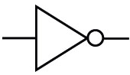 Name: [1]

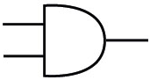 Name: [1]

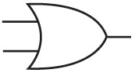 Name: [1]

(b) Draw the symbol for the following logic gates:
NAND gate [1]
NOR gate [1]
XOR gate [1]

(c) Explain the difference between an OR gate and an XOR gate. [2]

(d) Complete the following truth table for the circuit shown. [8]
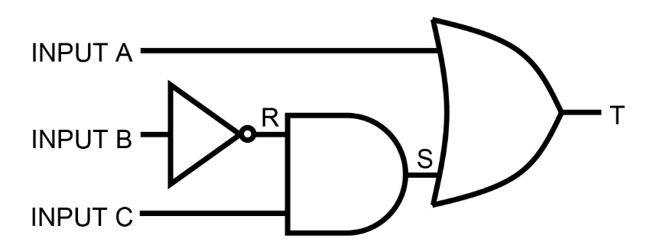

A | B | C | R | S | T
0 | 0 | 0
0 | 0 | 1
0 | 1 | 0
0 | 1 | 1
1 | 0 | 0
1 | 0 | 1
1 | 1 | 0
1 | 1 | 1
(e) Give the Boolean expression equivalent to the logic diagram. [2]

2. Tina has created a game that gives the user a score when the game finishes.
The highest score ever achieved by a player in the game is stored in a text file named
"Hi-score.txt".
When writing a program to read the high score, Tina first needs to open the file using the line of code:
OPEN "Hi-score.txt” FOR READ
(a) Explain what the syntax FOR READ means. [1]

(b) Complete the program so that the hi-score is read and stored in the variable
named HiScore. [2]
DECLARE HiScore : INTEGER
OPEN Hi-score.txt FOR READ

(c) The score the player achieves in the game is stored in a variable named PlayerScore.
Complete the program so that if PlayerScore is higher than the high score stored in HiScore, the PlayerScore will be stored in the file. [4]
DECLARE PlayerScore : INTEGER

(d) Describe how the use of functions could improve the program code that you
wrote in parts (b) and (c). [2]

(e) Give two reasons why it is important to use meaningful identifier names
in a program. [2]

3. The following function calculates a rail fare, based on the distance travelled. A discount of 10% is given for off-peak travel.
FUNCTION RailFare(distance, day, time)
IF distance < 5
THEN
RailFare 3.00
ELSE
IF distance < 12
THEN
RailFare 4.00
ELSE
RailFare 5.00
ENDIF
ENDIF

IF day = "Saturday" OR day = "Sunday"
THEN
RailFare 0.9 * RailFare
ELSE
IF time >= 10.00 and time < 16.00
THEN
RailFare 0.9 * RailFare
ENDIF
ENDIF
RETURN RailFare
ENDFUNCTION

What does the function return if it is called with each of the following statements?
(a) RailFare (4, "Monday", 8.00) [1]

(b) RailFare (15, "Saturday", 14.00) [1]

(c) RailFare (8, "Tuesday", 18.00) [1]

4. The following function returns a value when called.
FUNCTION Checkval(value, low, high)
IF value < low
THEN
RETURN "Low"
ELSE
IF value > high
THEN
RETURN "High"
ELSE
RETURN "OK"
ENDIF
ENDIF
ENDFUNCTION
(a) (i) Name one parameter used by the program. [1]

(ii) In the main program, the following statements are written.
OUTPUT "Please enter measurement: "
INPUT measurement
Write one or more statements which will call the function in order to check
whether the measurement is between 18 and 25, and output the result. [2]

(b) Give two reasons why programmers use functions and procedures. [2]

5. An estate agent keeps details of all the properties it has for rent.
An example of data from the table Rental is shown below.
PropertyID | Type | MonthlyRent | Beds | Furnished | DistanceToStation
1 | Apartment | £800.00 | 2 | Y | 0.3
2 | Semi | £475.00 | 2 | N | 1.5
3 | Apartment | £1150.00 | 3 | N | 0.5
4 | House | £1500.00 | 4 | Y | 0.2
5 | Apartment | £900.00 | 2 | Y | 0.3
6 | Apartment | £1250.00 | 3 | Y | 0.2
7 | Semi | £550.00 | 3 | Y | 2.4
8 | House | £600.00 | 3 | N | 0.6

(a) State the Property IDs of properties that will be found by the following queries:
(i) SELECT PropertyID
FROM Rental
WHERE MonthlyRent <= 550.00 OR Furnished = 'Y' [2]

(ii) SELECT PropertyID [1]
FROM Rental
WHERE Type = 'Apartment' AND DistanceToStation < 0.3

(b) Write an SQL query that displays the Type, MonthlyRent, Beds and Furnished
fields for all properties of type Semi or House which have at least 3 bedrooms. [4]

(c) What will the result of the following SQL query be? [3]
SELECT PropertyID, MonthlyRent
FROM Rental
WHERE Type = 'Apartment' AND Beds = 3
ORDER BY MonthlyRent DESC

(d) Write an SQL query that shows all details of all properties in the ascending
order of their distance from the station. [2]

(e) Write an SQL query that finds the total number of properties that are
available for rent. [1]

[Total 50 marks]

